**JAMIA HAMDARD**

**DEPARTMENT OF COMPUTER SCIENCE & ENGINEERING**

*School of Engineering Sciences & Technology*



**Assignment on:**

OOPS Lab

| **Prepared by:**  **Mohd Athar**  JH23-PGP-01236  MCA – 1st Year, 1st Semester | | | **Submitted to:**  Dr. Sahab Saquib Sohail Sir |
| --- | --- | --- | --- |
|  | **Signature** |  |  |

**Ques 1.** Write a program in c++ to perform arithmetic operations with three integer variables.

**Soln.**

#include <iostream>

using namespace std;

int main()

{

int n1,n2,n3,r;

// Taking three integers as input from user

cout<<"Enter three integers: "<<endl;

cin>> n1>>n2>>n3;

int choice;

cout<<"1 For Addition"<<endl;

cout<<"2 For Substraction"<<endl;

cout<<"3 For Multiplication"<<endl;

cout<<"4 For Division"<<endl;

cout<<"Enter Your Preffered Option: "<<endl;

cin>> choice;

switch (choice){

case 1:

cout<<"Result of Addition is: "<<n1+n2+n3;

break;

case 2:

cout<<"Result of Subtraction is: "<<n1-n2-n3;

break;

case 3:

cout<<"Result of Multiplication is: "<<n1*n2*n3;

break;

case 4:

if (n2!=0 && n3!=0){

r=n1/(n2*n3);

cout <<"Result of Division is: " <<r<<endl;

}

else {

cout<<"Division is not allowed!";}

break;

default:

cout<<"Invalid Choice";

return 0;

}

}

For Addition:

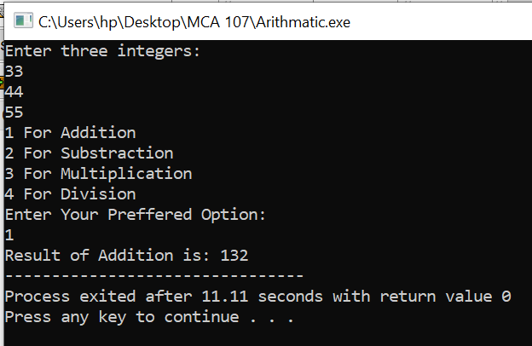

For Subtraction:

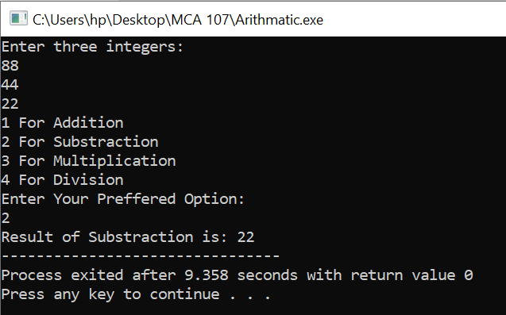

For Multiplication:

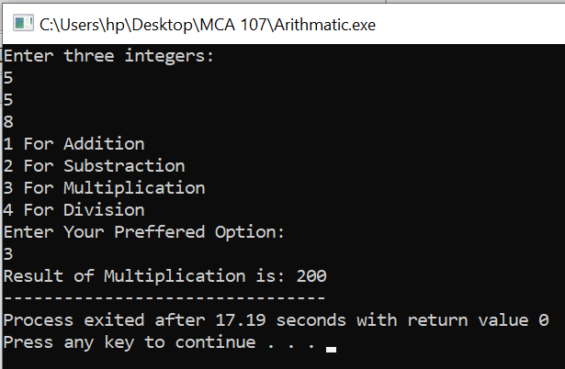

For Division:

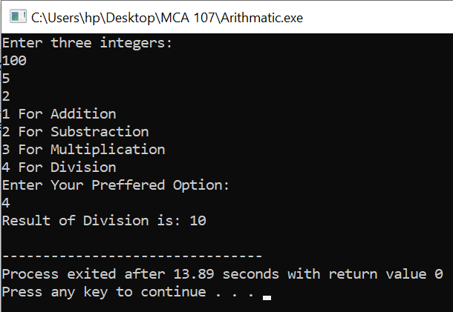

**Ques 2.** Without using third variable, swap the value of two variables.

**Soln.**

#include<iostream>

using namespace std;

int main() {

int a, b;

// Input the values of a and b

cout << "Enter the value of a: ";

cin >> a;

cout << "Enter the value of b: ";

cin >> b;

// Swap a and b without using a third variable

a = a + b;

b = a - b;

a = a - b;

// Output the swapped values

cout << "After swapping, a = " << a << " and b = " << b << endl;

return 0;

}

Result:

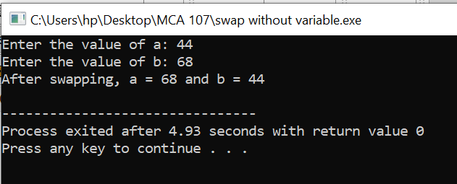

**Ques 3.** Write a program in c++ to print Fibonacci series.

**Soln.**

#include <iostream>

using namespace std;

int main() {

int n;

// Input the number of terms you want in the Fibonacci series

cout << "Enter the number of Fibonacci terms you want to generate: ";

cin >> n;

int first = 0, second = 1;

cout << "Fibonacci Series up to " << n << " terms: ";

// Print the first two terms of the Fibonacci series

cout << first << " " << second << " ";

for (int i = 2; i < n; i++) {

int next = first + second;

cout << next << " ";

first = second;

second = next;

}

cout << endl;

return 0;

}

Result:

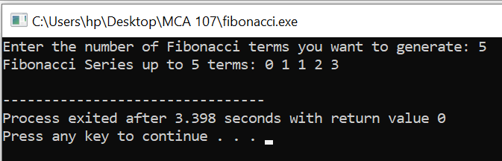

**Ques 4.** You are given a number, write a program in c++ to check whether the number is prime or not?

**Soln.**

#include <iostream>

using namespace std;

bool isPrime(int n) {

// Handle special cases

if (n <= 1) {

return false;

}

// Check for divisibility from 2 to the square root of n

for (int i = 2; i * i <= n; i++) {

if (n % i == 0) {

return false; // n is divisible by i, so it's not prime

}

}

return true; // If no divisors were found, n is prime

}

int main() {

int num;

// Input a number from the user

cout << "Enter a number: ";

cin >> num;

if (isPrime(num)) {

cout << num << " is a prime number." << endl;

} else {

cout << num << " is not a prime number." << endl;

}

return 0;

}

Result:

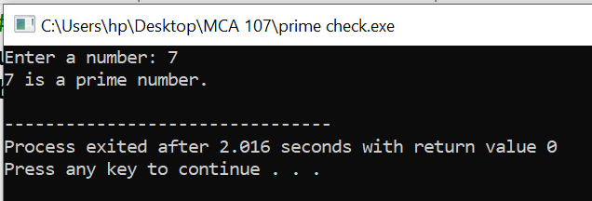

**Ques 5.** Write a program in c++ to print ‘*’ (Asterisk) in triangle form.

**Soln.**

#include <iostream>

using namespace std;

int main() {

int n;

// Input the number of rows for the triangle

cout << "Enter the number of rows for the triangle: ";

cin >> n;

// Outer loop to iterate through rows

for (int i = 1; i <= n; i++) {

// Inner loop to print asterisks in each row

for (int j = 1; j <= i; j++) {

cout << "* ";

}

cout << endl;

}

return 0;

}

Result:

